Germination (<http://horticulturejournal.usamv.ro/pdf/2015/art69.pdf>)

* Regarding pre-germination treatments results have revealed that seed incubation in exfoliated vermiculite (1.12 g seed in 157 g vermiculite) moistened with 2 g H20 g -1 dry weight vermiculite for 1 day at 20 0 C resulted in a 21% increase in shoot fresh weight by 14 days after planting
* Growing media should have a pH of 5.5–6.5

Thuya’s Research:

Questions:

* Temperature to instill germination

( Seeds generally “wake up” and germinate when soil moisture and temperature conditions are correct for them to grow)

[Germination Temperature](http://sacmg.ucanr.edu/files/164220.pdf)

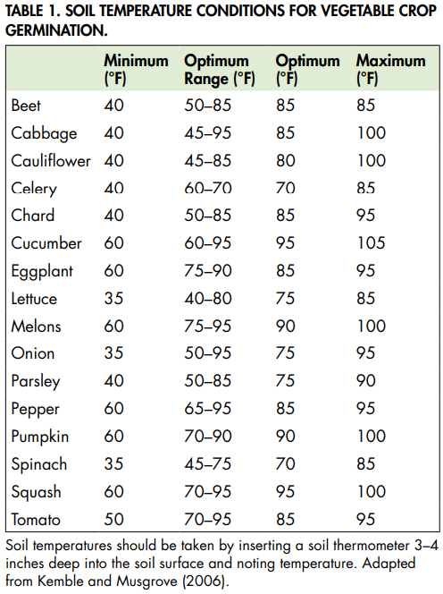

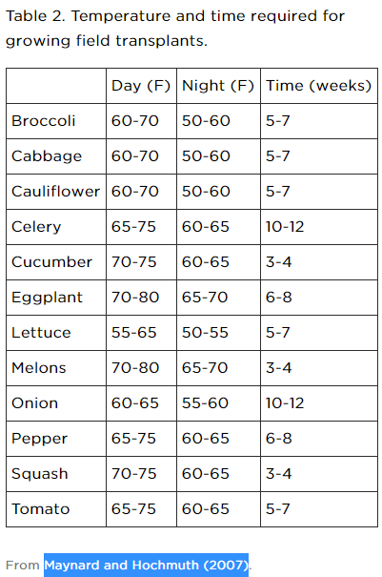

[Organic Seed Sources](https://extension.psu.edu/seed-and-seedling-biology) - Also for the data above

[Temperatures for plant to grow optimal](http://sacmg.ucanr.edu/files/164220.pdf)

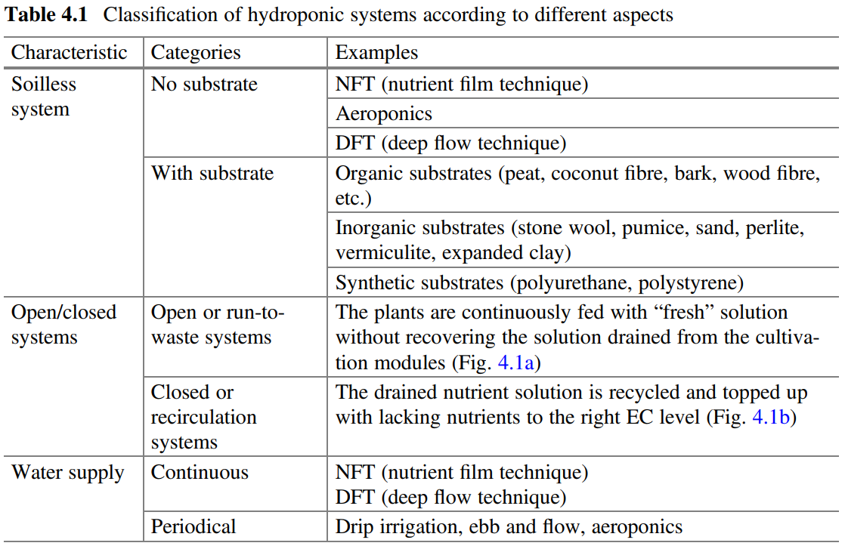

Water-Holding Capacity Water-holding capacity ensures adequate levels of substrate moisture for crops, without having to resort to frequent irrigations. However, the water-holding capacity must not be too high in order to avoid root asphyxia and too much cooling

2019_Book_AquaponicsFoodProductionSystem - Aquaponics ideal conditions data

[Germination Time for plants](http://www.tradewindsfruit.com/content/seed-germination-tips.htm#:~:text=Seeds%20usually%20germinate%20within%202%2D6%20weeks%20at%2075%2D85F.,-Psidium%20species&text=Variable%2C%20some%20seeds%20sprout%20within%201%2D3%20weeks%2C%20others,85F%20for%20reliable%20germination%20results.)

[Microgreens germination](https://www.bootstrapfarmer.com/blogs/microgreens/the-ultimate-microgreen-cheat-sheet)

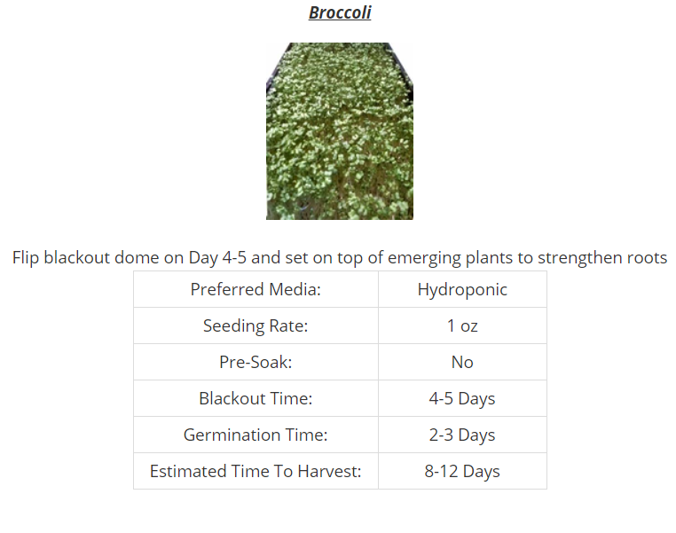

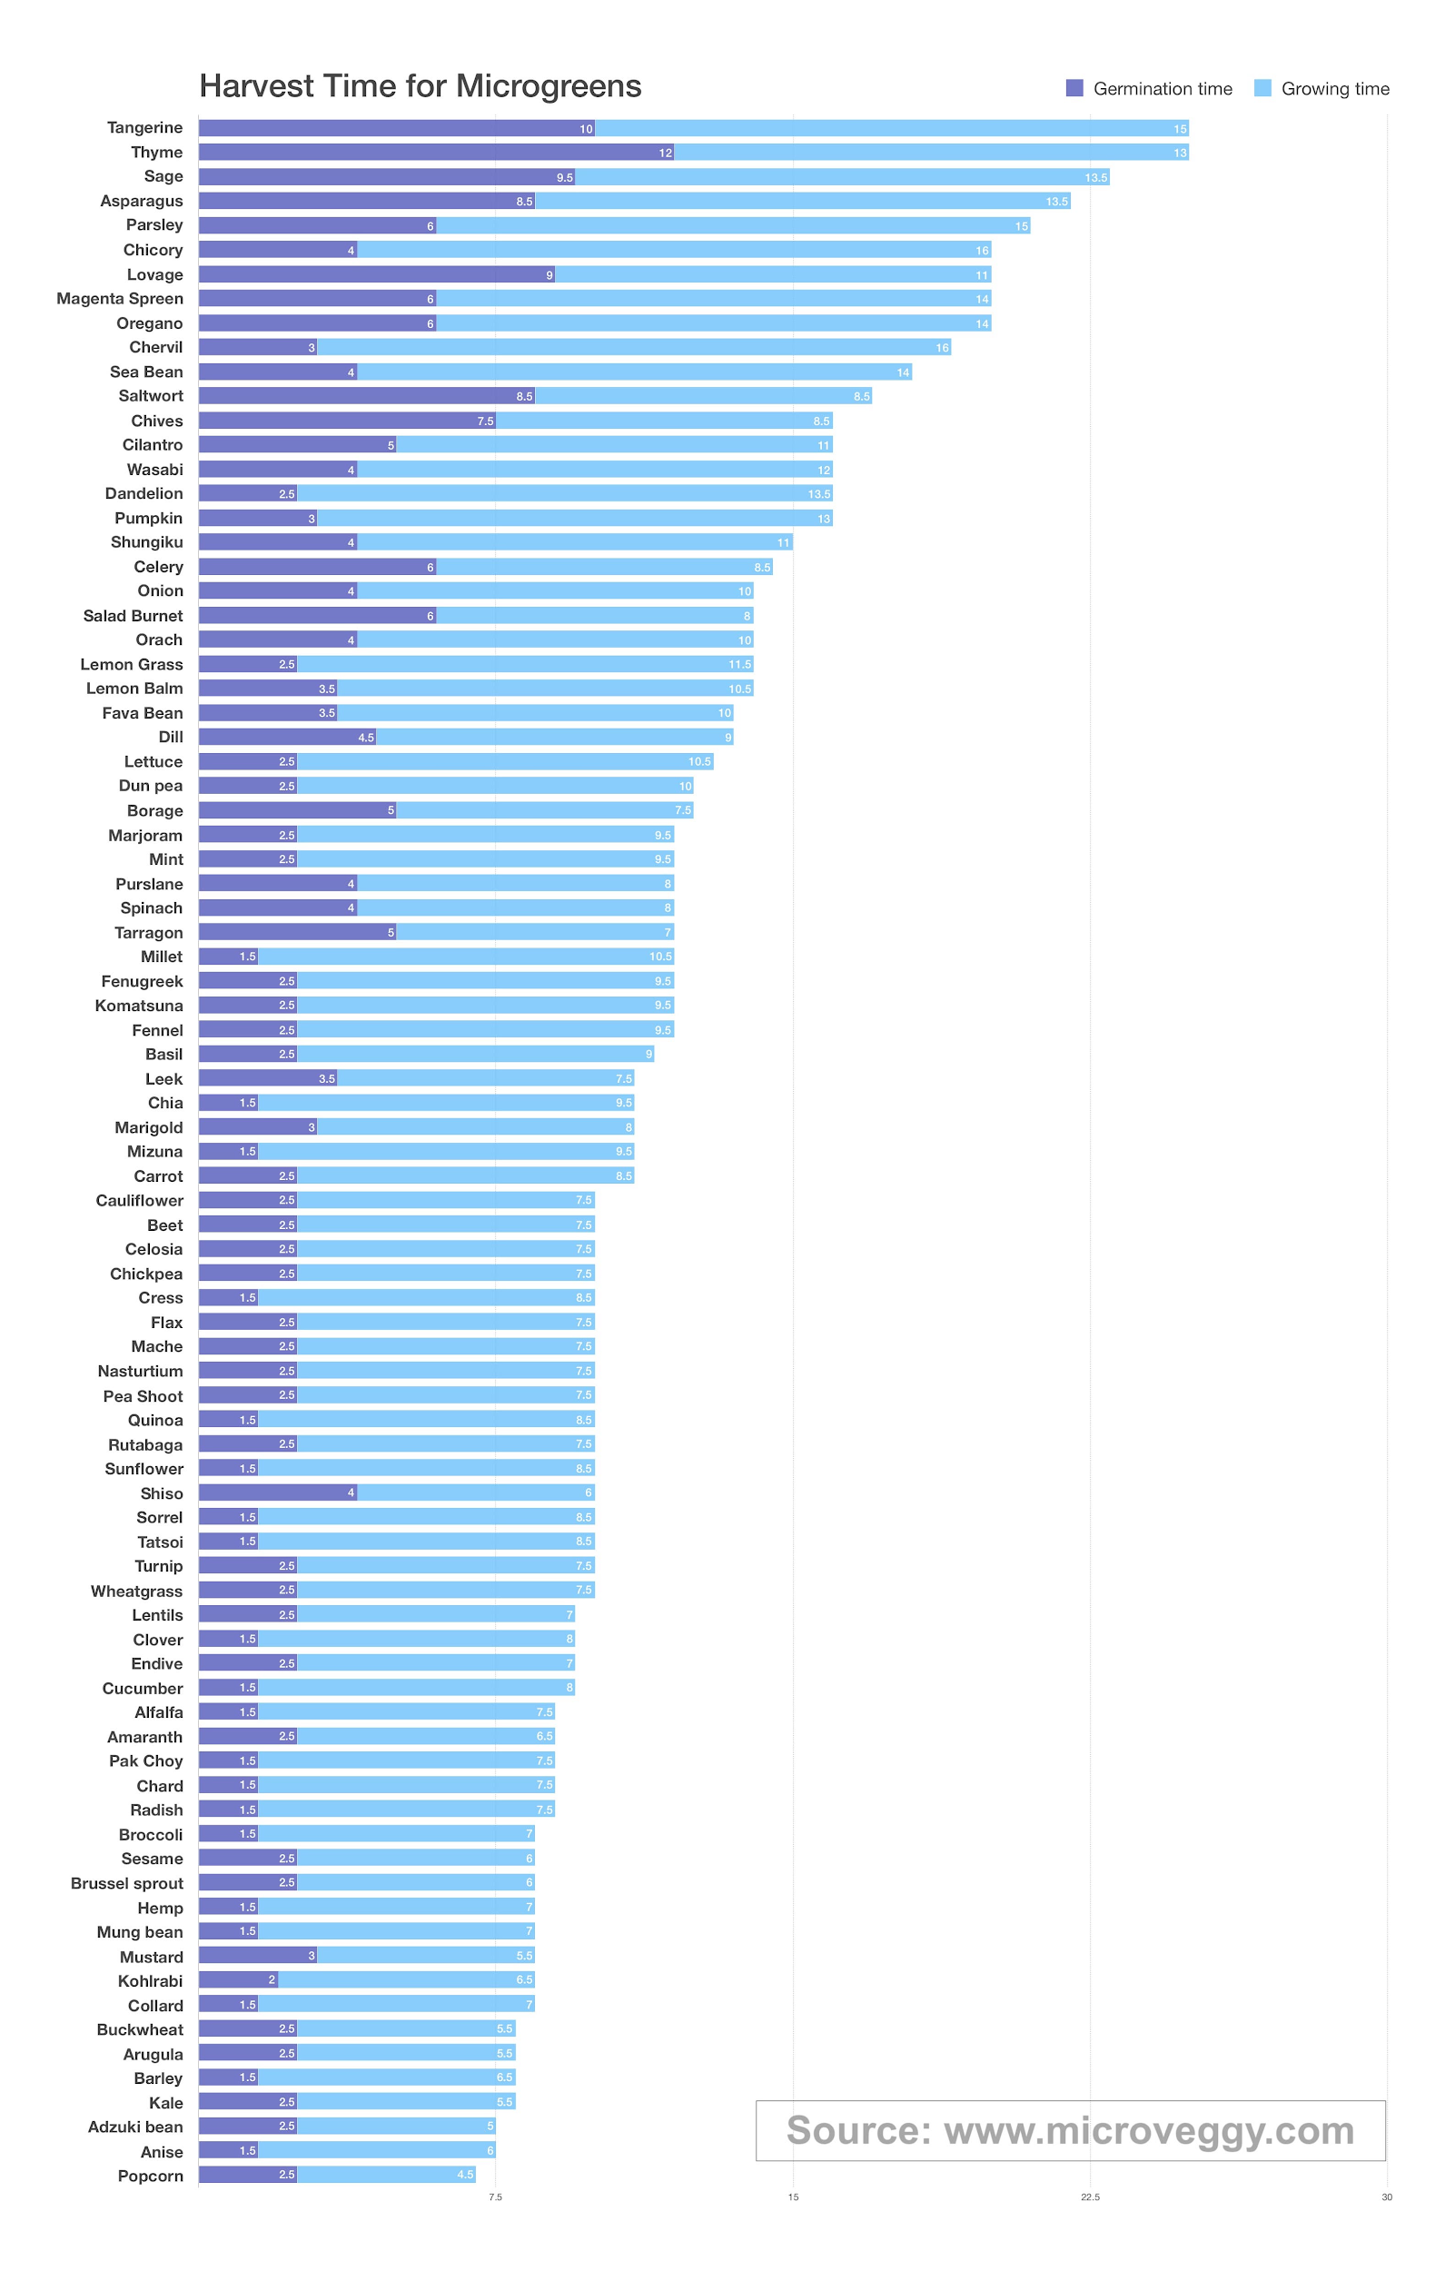

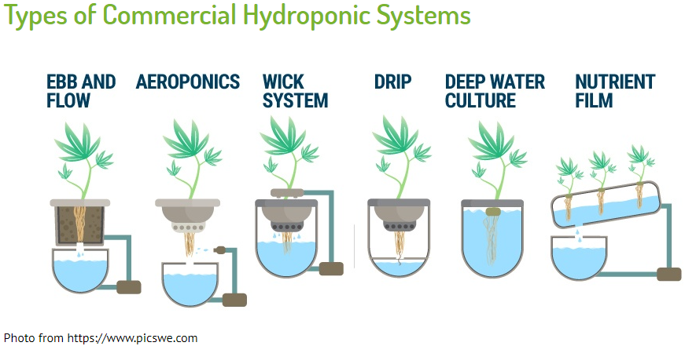[Types of ways growing plants](https://grocycle.com/hydroponic-microgreens/)

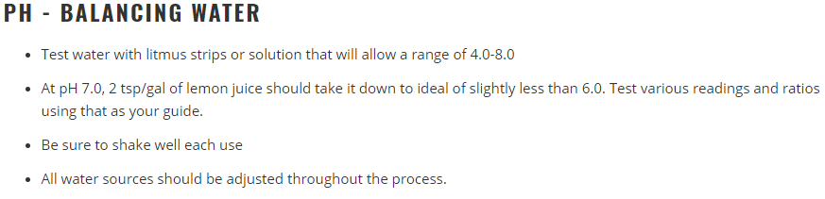

[Blackout Microgreens](https://homemicrogreens.com/cover-microgreen-seeds/)

[Soaking Microgreens](https://homemicrogreens.com/growing-sunflower-microgreens-presoaking-the-seed/)

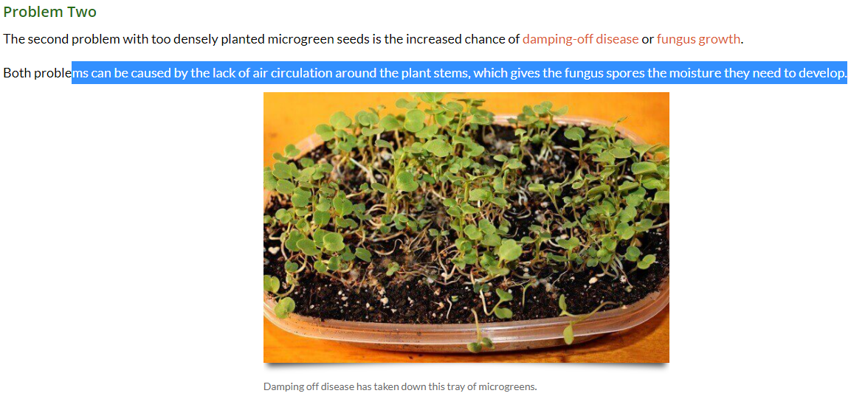

[Seed Density](https://homemicrogreens.com/why-microgreen-seed-density-is-important/)

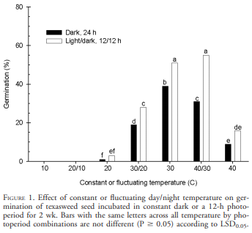

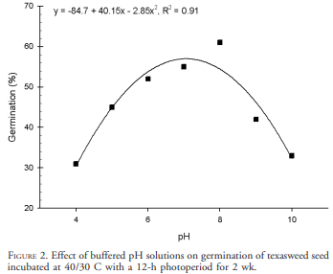

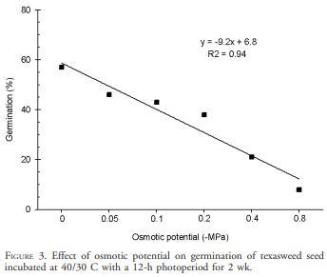

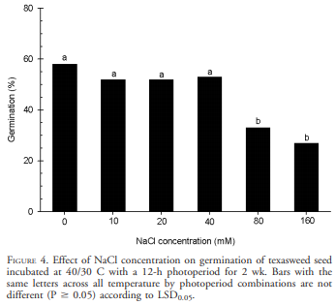

[Plant germination ^^](https://www.ars.usda.gov/ARSUserFiles/64022000/Publications/Reddy/Kogetetal04WS52-6-989.pdf)

[waste water hydroponics](https://www.researchgate.net/publication/262456741_Reuse_of_hydroponic_waste_solution)

[Ways to increase germination](https://www.intechopen.com/books/advances-in-seed-biology/seed-dormancy)

[inhibitions to germination](https://www.ck12.org/book/ck-12-biology-advanced-concepts/section/13.50/)

